**HEART DISEASE PREDICTION AND CURE**

**Abstract:**

Adverse drug events remain a leading cause of morbidity and mortality around the world. Many adverse events are not detected during clinical trials before a drug receives approval for use in the clinic. Fortunately, as part of post marketing surveillance, regulatory agencies and other institutions maintain large collections of adverse event reports, and these databases present an opportunity to study drug effects from patient population data.

However, confounding factors such as concomitant medications, patient demographics, patient medical histories, and reasons for prescribing a drug often are uncharacterized in spontaneous reporting systems, and these omissions can limit the use of quantitative signal detection methods used in the analysis of such data. Here, we present an adaptive big data-driven approach for correcting these factors in cases for which the covariates are unknown or unmeasured and combine this approach with existing methods to improve analyses of drug effects using three test data sets. Shows the nearby medicals to user wherever that medicines are available.

**Problem Statement:**

Establishing the system for solving the problems like uncertainty of Heart diseases, traditional approaches of drug procurement planning in hospitals that often cause drug overstocking or understocking, which can have strong negative effects on healthcare services.

**Scope :**

The future scope of this system is aimed at offering a big data infrastructure for our designed risk calculation tools, to design more sophisticated prediction models and feature extraction techniques and extend our proposed system to predict other clinical risks. To predict the Heart disease using svm algorithm.

Some other future possibilities are for the discovery of ground-breaking pharmaceuticals, the development of more effective treatment protocols and for the development of personalized medicine

**Objective :**

To examine current standards, methods, and uses for big data to develop a morbidities prediction system to assist providers in establishing higher standards of care, suggesting particular drugs for curing the disease and a more personalized medical care plan for the patient. According to user Report we predict the disease .

**Proposed System-**

A big-data driven approach, which uses a deep neural network to predict morbidities of acute gastrointestinal infections based on a huge amount of environmental data, and then constructs an optimization problem of drug procurement planning for maximizing the expected therapeutic effect on the predicted cases. The problem is solved by an efficient heuristic optimization algorithm.

**When user enters symptoms,**

* system analyse that symptoms with big data
* Detect the Heart disease he is suffering from
* recommend appropriate medicines to cure that disease

**System Architecture:**

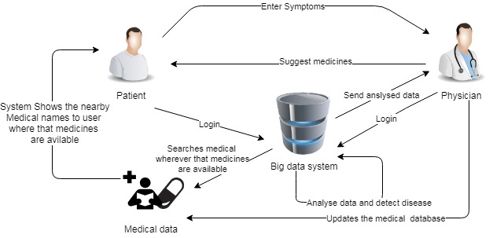

**System Architecture**

**Conclusion:**

Big data analytics has the potential to transform the way healthcare providers use sophisticated technologies to gain insight from their clinical and other data repositories and make informed decisions. In the future we’ll see the rapid, widespread implementation and use of big data analytics across the healthcare organization and the healthcare industry. To that end, the several challenges highlighted above, must be addressed. As big data analytics becomes more mainstream, issues such as guaranteeing privacy, safeguarding security, establishing standards and governance, and continually improving the tools and technologies will garner attention. Big data analytics and applications in healthcare are at a nascent stage of development, but rapid advances in platforms and tools can accelerate their maturing process.

Dataset of this module contains multiple medical stores’ information. Only Admin can have access to this. Admin adds the medical information to database and whenever user searches system shows him nearby stores.

**REFERENCES:**

1. J. D. Quick, “Applying management science in developing countries: ABC analysis to plan public drug procurement,” Socio-Eco. Plan. Sci., vol. 16, no. 1, pp. 39–50, 1982.
2. M. Duggan and F. M. Scott Morton, “The distortionary effects of government procurement: Evidence from medicaid prescription drug purchasing,” Quar. J. Eco., vol. 121, no. 1, pp. 1–30, 2006.
3. Y. Shu and R. Tong, “Common problems of hospital drugs procurement and its solutions,” China Pharm., vol. 22, no. 33, pp. 3114–3115, 2011.
4. P. V. Singh, A. Tatambhotla, and R. R. Kalvakuntla, “Replicating Tamil Nadu’s drug procurement model,” Eco. Polit. Weekly, vol. 47, no. 39, pp. 26–29, 2012.
5. A. L. Kjos, N. T. Binh, C. Robertson, and J. Rovers, “A drug procurement, storage and distribution model in public hospitals in a developing country,” Res. Social Admin. Pharm., vol. 12, no. 3, pp. 371–383, 2016.
6. J. Federmann and V. Fikr, “Mathematical model for the prediction of drug consumption. I. correlative analysis of consumption factors,” Ceskoslovenske Zdravotnictvi, vol. 18, no. 2, pp. 65–73, 1970.
7. E. Iosifidis, C. Antachopoulos, M. Tsivitanidou, A. Katragkou, E. Farmaki, M. Tsiakou, T. Kyriazi, and D. S. E. Roilides, “Differential correlation between rates of antimicrobial drug consumption and prevalence of antimicrobial resistance in a tertiary care hospital in Greece,” Infection Control Hospital Epidem., vol. 29, no. 7, pp. 615–622, 2008.
8. W. Wang, W. Zhang, J. Yin, and R. Xu, “A simple seasonal autoregressive model and its application in drug demand forecasting,” Chinese J. Health Stat., vol. 14, no. 2, pp. 46–47, 1997.
9. C.-h. Hu, “Research on the dynamic demand model of drugs,” Chinese Journal of Pharmaceutical Analysis, vol. 30, no. 11, pp. 2229–2232, 2010.
10. M. S. Sohn, “Demand forecasting for developing drug inventory control model in a university hospital,” Korean Journal of Preventive Medicine, vol. 16, no. 1, pp. 113–120, 1983.